Data Mining Assignment 3

1) Read Chapter 6 (only sections 6.1 and 6.7).  
  
2) Do Chapter 6 textbook problem #2 (parts a,b,c,d only) on page 404.

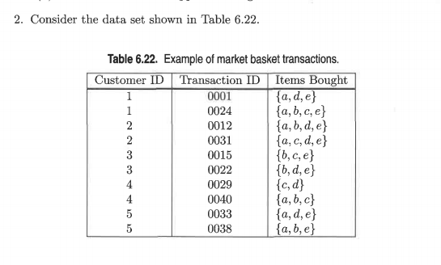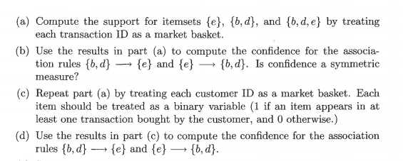

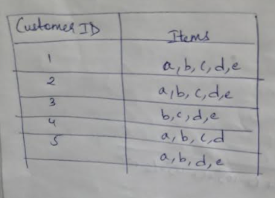



3) Do Chapter 6 textbook problem #6 (parts d,e only) on page 406.

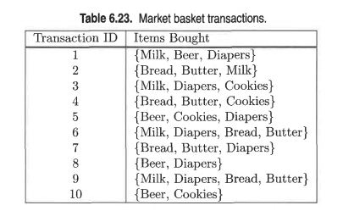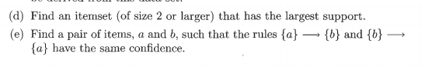

d) {Bread, Butter}

e) {Beer, Cookies}, {Bread, Butter}  
  
4) Using the data at [www.stats202.com/more_stats202_logs.txt](http://www.stats202.com/more_stats202_logs.txt) and treating each row as a "market basket" compute the support and confidence for the rule ip=65.57.245.11 → "Mozilla/5.0 (X11; U; Linux i686 (x86_64); en-US; rv:1.8.1.3) Gecko/20070309 Firefox/2.0.0.3".

State what the support and confidence values mean in plain English in this context.

* Support is an indication of how frequently the items appear in the data.
* Confidence can be interpreted as the likelihood of occurring both IP addresses and links together.